Employee Management System

Student ID

Name

Date

Contents
1. Introduction 2
2. Design 3
3. Testing 8
4. Conclusion 10
References 11

1. Introduction
This project is a proposal that outlines the design and implementation of an Employee Management System that is being written in C# NET in the form of a console-based application. The system is to be used to regulate the employee databases and related leave requests in a highly organized and productive way. It is able to offer basic features of adding employee profiles, searching employee data, leaving request records, and stored information. The project approximates a real organisational need where the effective way of tracking the employees and retrieving data would be critical in the effectiveness of the organisation.
The main concern this project deals with is the choice and the adoption of a proper data structure in facilitating efficient search and data management. The system is not based on any in-built collections and is instead built on a custom-designed data structure demonstrating good knowledge of what constitutes an algorithmic design and complexity analysis. The methodology is consistent with the coursework requirement of prioritizing the implementation of the data structure and the performance analysis (Košt’ál, I., 2023).
Maintainability and transparency are also focused on the development of this system using the principles of an object-oriented design. The data structure and the employees, leave records and the employees are represented in separate classes, making them easy to extend and modular. Also, file management is added to enable permanent storage of information, which is the further improvement of the practicality of the system.
In this report there are four major sections. Design section discusses how the system will be designed, the reasons why the chosen data structure is so, and the explanation of the main algorithms, based on the pseudo code. Testing section explains the method of testing followed and gives a structured table of test cases to confirm the functionality of the system. Conclusion section summarises the work done, discusses limitations, and gives a critical commentary of how the work was developed with some improvements that could be made in the future. Lastly, the references are in Harvard style to back up the theoretical basis of the work.

2. Design
The Employee Management System design is pegged on the efficient data storage and retrieval coupled with an easy to understand and modular design. It is a system that is applied based on object oriented principles with every component being encapsulated in a particular class. The main classes are the Employee class and the LeaveRecord class that stores the information of the employee, e.g., the ID and name, department and position etc. and the information of the employee leave application respectively. These classes are supposed to depict real-world entities and so, the structure of the system should be closely related to the practical cases.
The very heart of the system is the implementation of the Binary Search Tree (BST) data structure that will be the central data structure of keeping the records of the employees. A BST has a node with an Employee object and an allusion to right and left child nodes. The tree is ordered in terms of the employee IDs whereby all the nodes in the left subtree have smaller IDs and those in the right subtree have bigger IDs. This structural feature allows efficient search, insertion and traversal (Jangra, S., 2023).
The Binary Search Tree is chosen due to the nature of the performance and its applicability to the problem domain. Efficient searching is also one of the primary needs of the system because the users often have to find the records of the employees. In comparison with linear data structures, e.g., arrays or linked lists, which take O(n) time to execute search operations, a BST has an average-case complexity of O(log n). This is a huge performance enhancement especially when the size of the dataset increases. Moreover, the BST stores information in sorted sequence and this enables it to be traversed in a structured way and easier data management.
Other data structures were also in the process of design. Rejection of arrays was based on the fixed size and the ineffective insertion operations, where the array can require the movement of elements. Linked lists were not also considered appropriate because they had a linear search complexity, in spite of the fact that they were dynamic in size. Hash tables were proposed but not chosen, as they do not inherently keep order and would not fit in the coursework requirement of clearly showing the algorithm design and traversal logic (Panjuta, D. 2024). Thus, Binary Search Tree has been the best decision in terms of efficiency, readability, and educative quality.
In the BST, insertion algorithm is done recursively. When an additional employee is introduced to the network, the algorithm compares the ID of the employee and the ID of the existing node. In case the new ID is smaller, the algorithm will move to the left subtree, or in case it is bigger, it will move to the right subtree. This will repeat until one gets an empty spot, and a new node is inserted there. The pseudo code of this operation will be as follows:

FUNCTION Insert(node, employee)
IF node is NULL
new node has employee
IF employee.ID = node.employee.ID<|human|>Much of the work has been done by the time this is published, and these fallacies are certainly not new.<|human|>When it comes down to publishing this, a lot of the work is already done and these fallacies are by no means new.
node.left = Insert (node. left, employee)
ELSE IF employee id is larger than node.employee id.
node.right=Insert(node.right, employee)
RETURN node
Search algorithm is also made recursive and it has similar logic of traversal. The algorithm then compares the target ID with the current node ID and then moves to either left or right subtree respectively (Golmohammadi, 2023). This will be efficient since only a subset of the nodes will be explored. The pseudo code is as follows:
FUNCTION Search(node, id)
IF node.employee.ID=id OR node is NULL.
RETURN node
IF id < node.employee.ID
RETURN Search(node.left, id)
ELSE
RETURN Search(node.right, id)

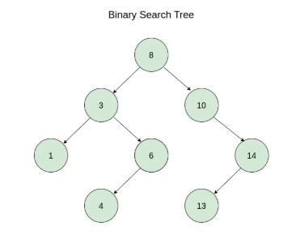
Figure 1: BST c/f https://www.geeksforgeeks.org/java/java-program-to-construct-a-binary-search-tree/
Along with the ID search, the system also allows the search by the name of an employee. As the BST is not sorted by name, such an operation necessitates a complete push through the tree. A search query is in-orderedly traversed to all the nodes and a match of each node on the query is checked. Although this operation has a time complexity of O (n), it must be able to enable flexible search functionality.
The system also involves the provision of leave record management capability. Every Employee object has a set of leave records, which means that there can be several leave records on one employee. Once a leave is tacked, the system carries out a search operation to find the employee and then the record of the leave is added. This shows the combination of various data structures in the system (Sigüenza Vilella, 2025).
Another significant factor to consider in the design is the time complexity of the essential operations. On average, an insertion and a search on a BST would both take the time complexity of O(log n) when the tree is balanced. But worst case is when the tree is skewed because of successive insertions, the complexity is reduced to O(n). This weakness is admitted and elaborated in the conclusion section.
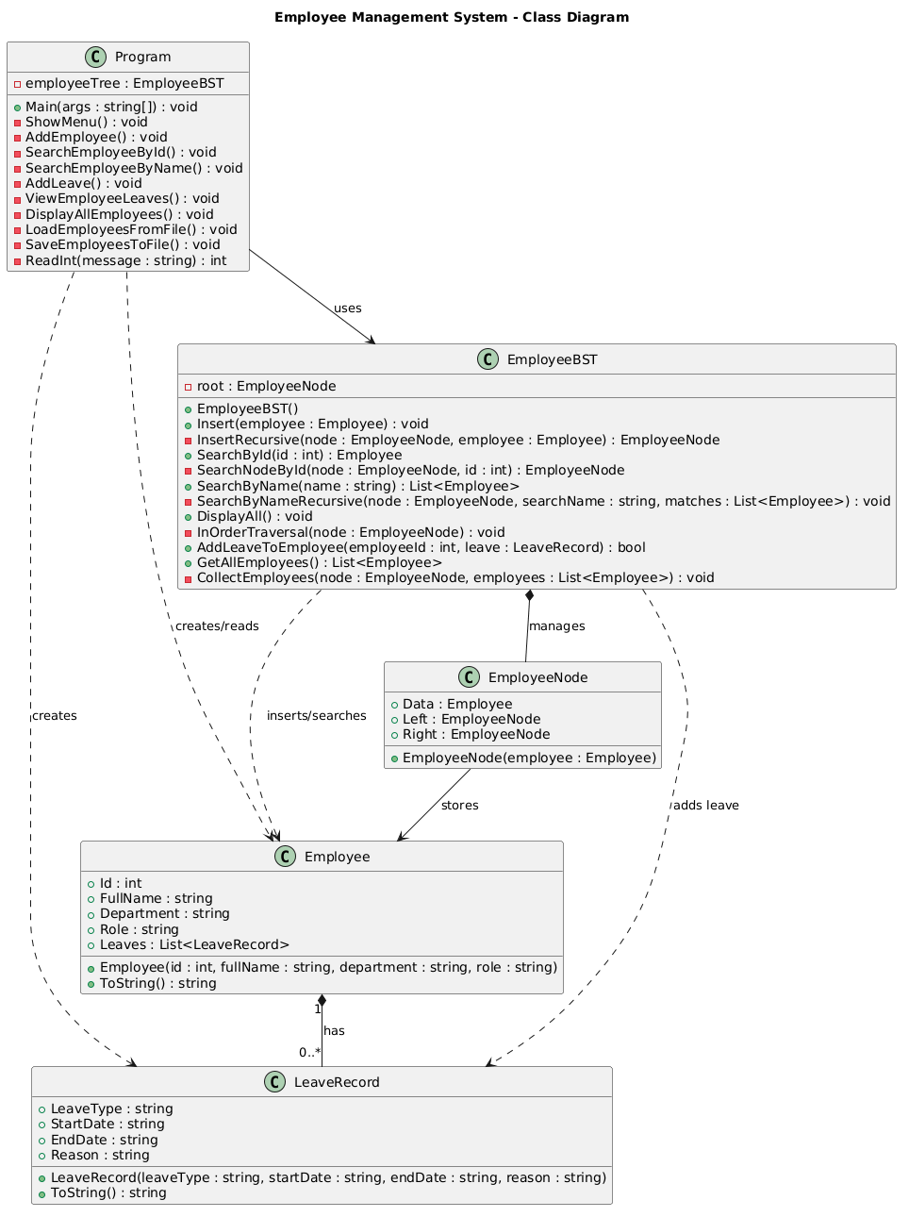
Figure 2: Class Diagram
All in all, the system design is a good balance of performance, readability, and maintenance. Utilisation of a Binary Search Tree not only guarantees the efficient data handling but also satisfies the coursework requirement of the implementation of a custom data structure and analysis of its behavior (Panjuta, D., 2024).

3. Testing
The testing process in the software development process is also important since it confirms the functionality of the system and that it is designed to satisfy the stipulated requirements. A formal testing method was used in this project that involves manual testing and functional validation. The aim was to ensure every feature works as intended and that the system can be expected to act reliably within various conditions (Griffiths, 2022).
The testing was commenced at the unit level with the validation of the individual components. All the core functions, which included the employee insertion, searching and leave management were tested separately so as to be correct. This strategy assisted in isolating possible problems and enabled specific debugging (Akella, R., 2022). This was followed by integration testing; this was done to verify the system so that various components interact properly.
Testing of search functionality was also a major priority since the most important reason of the data structure was the search functionality. Different scenarios were put into test such as search of existing, search of non-existing employees as well as search with partial names. The findings validated the fact that the BST implementation offers relevant and effective search results (Jamro, M., 2024).
Testing was also concerned with input validation. The invalid inputs were also tested on the system to make sure that the system is capable of handling errors without crashing down, like inputting non-numeric values as the employee IDs. This adds strength and stability of the system (Shoykulov, S., 2024). While handling functionality was also experimented by loading employee data using a file and saving data using a file. To make sure that data are properly parsed and stored these operations were checked. This aspect is very vital in showing the persistence of data and fulfilling the coursework requirements.
The table below summarises the major test cases that were involved in testing:
Test Case ID | Description | Input | Expected Output | Result
TC01 | Add valid employee | ID=101 | Employee added successfully | Pass
TC02 | Add duplicate employee | ID=101 | Error message displayed | Pass
TC03 | Search by valid ID | 101 | Employee details shown | Pass
TC04 | Search invalid ID | 999 | Employee not found | Pass
TC05 | Search by name | "Ali" | Matching employees listed | Pass
TC06 | Add leave record | Valid data | Leave added successfully | Pass
TC07 | View leave records | Employee with leaves | Leave details displayed | Pass
TC08 | Load from file | Valid file | Employees loaded | Pass
TC09 | Save to file | output.txt | File created successfully | Pass
TC10 | Invalid input | Text instead of number | Error handled correctly | Pass

As the results of the testing show, the system is reliable in all the basic functionalities. The development was met with any minor problem that was detected and addressed by means of iterative testing. All in all, the testing process proves that the system is in compliance with its functional requirements and it is expected to operate.

4. Conclusion
This project has managed to fulfill its goal that included the design and implementation of an Employee Management System in C#.NET. The system offers a working solution to processing employee records and leave applications, and it shows the positive application of data structure and algorithms. A Binary Search Tree is a data structure that allows effective storage and access to the data to meet the main demand of the coursework, as it has been implemented as its center.
The project also displays good knowledge in major programming concepts like object-oriented design, recursion, and complexity analysis. The system is maintainable, modular and can support the necessary operations like insertion, searching and data persistence. Moreover, file manipulation and SQL script are added to make the system more practical.
Nevertheless, there were a number of limitations that were noted in the development process. This is because the Binary Search Tree may be imbalanced and slow down in the worst-case scenario, which is considered the greatest weakness of this algorithm. The reason behind this problem is that there is no self-balancing mechanism, i.e. AVL or Red-Black Trees. Also, the interface is console based, restricting the interactions between the user and does not offer the usability that is required in the current-day applications. The second constraint is that it is not fully integrated with a live database constraining the scalability of the system and application in reality.
The critical reflection of the process of development shows that the aspects of scalability and performance optimisation should have been taken into consideration more closely in the design stage. Although the BST was up to the minimum of standards, a more sophisticated data structure might have been taken into account to guarantee the same level of performance. Also a more organized development process, like incremental prototyping or using an automated testing process, would have provided better efficiency and shortened development time.
A number of enhancements can be made to the system in the future. The use of a self-balancing tree would mean that there would be uniform performance in all situations. The creation of a graphical user interface would provide a lot of ease and accessibility to users. The system should be integrated with a relational database using SQL to have a stronger ability of data management. Also automated testing platforms like MSTest would be implemented to enhance reliability and maintainability.

Finally, it can be concluded that this project is a good example of data structure implementation and algorithm analysis in a real-life application. It points out the advantages as well as the shortcomings of the selected strategy and offers a strong basis to further growth.

References
Košt’ál, I., 2023, September. Execution Efficiency of a Sequential, Multi-Threaded, and a Parallel Search for a Structured Data in a Symbol Table Implemented in a Binary Search Tree, an Array, and in a Linked List. In International Conference on Global Research and Education (pp. 316-332). Cham: Springer Nature Switzerland.
Microsoft (2024) C# Documentation. Available at: https://learn.microsoft.com (Accessed: 2026).
Jangra, S., Singh, G., Mantri, A., Angra, S. and Sharma, B., 2023, July. Interactivity development using Unity 3D software and C# programming. In 2023 14th International Conference on Computing Communication and Networking Technologies (ICCCNT) (pp. 1-6). IEEE.
Panjuta, D. and Jabbarzadeh, J., 2024. Learning C# Through Small Projects (pp. 1-391). Springer.
Golmohammadi, A., Zhang, M. and Arcuri, A., 2023. . NET/C# instrumentation for search-based software testing. Software Quality Journal, 31(4), pp.1439-1465.
Sigüenza Vilella, A., 2025. Design and implementation of a graphic console for a home automation system focused on security.
Griffiths, I., 2022. Programming C# 10: Build Cloud, Web, and Desktop Applications. " O'Reilly Media, Inc.".
Akella, R., Tamirisa, A.K., Kunani, S.K. and Muthiyalu, B.G., 2022. Enterprise Application Development with C# 10 and. NET 6: Become a professional. NET developer by learning expert techniques for building scalable applications. Packt Publishing Ltd.
Shoykulov, S., 2024. Analysis and optimization of graphics programming in C# using Unity. Science and innovation, 3(A10), pp.69-75.
Panjuta, D. and Jabbarzadeh, J., 2024. C# Data Types and Variables. In Learning C# Through Small Projects (pp. 23-43). Cham: Springer Nature Switzerland.
Panjuta, D. and Jabbarzadeh, J., 2024. C# Operators and Conditionals. In Learning C# Through Small Projects (pp. 45-71). Cham: Springer Nature Switzerland.
Jamro, M., 2024. C# Data Structures and Algorithms: Harness the power of C# to build a diverse range of efficient applications. Packt Publishing Ltd.

